Module: Purchasing
Topic: Reporting
Purchase Orders By G/L Account Enterprise ERP Version 21.7
This report shows open Purchase Orders

= enc/req on the ytd budget report

Procedure
Use the following steps to view the listed report.

Purchase Orders by GL Account

The Purchase Orders by General Ledger (GL) Account program provides a report of purchase orders by general ledger account or by general ledger segment. Prior to running this report, Accounts Payable Invoice Entry/Proof and PO Entry/Proof data need to be posted.

This report can be used to compare purchase orders in the system for a particular GL account against what is showing in the GL Account Inquiry to locate discrepancies.

To Run the Report:

Open Purchase Order by GL Account by clicking on Departmental Functions > Purchase Orders by GL Account

Once you click on Purchase Orders By G/L Account the following screen will appear:

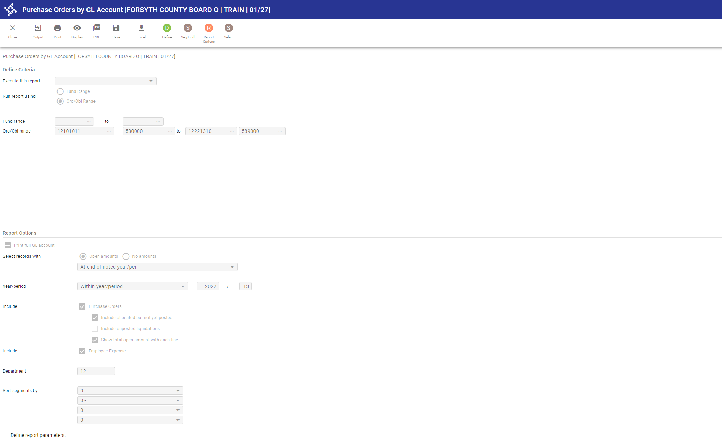

Now click on the button and enter the following information in the Org/Obj range, depending on your school. Note that XX is the 2 digit school code:

Elementary XX101011 530000 TO XX221310 589000
Middle XX101081 530000 TO XX221310 589000
High XX101041 530000 TO XX221310 589000

Alternately, you can specify a single Org/Object.

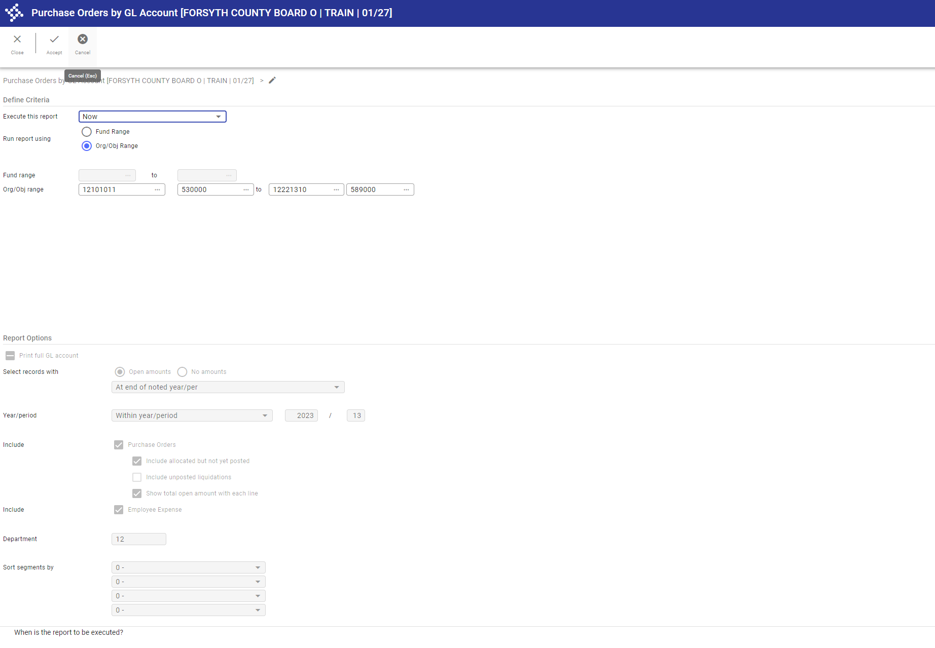

Click on the 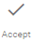 button to accept this input.

Now click on the 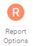 button and enter the following information:

  - Year/Period
  - Department

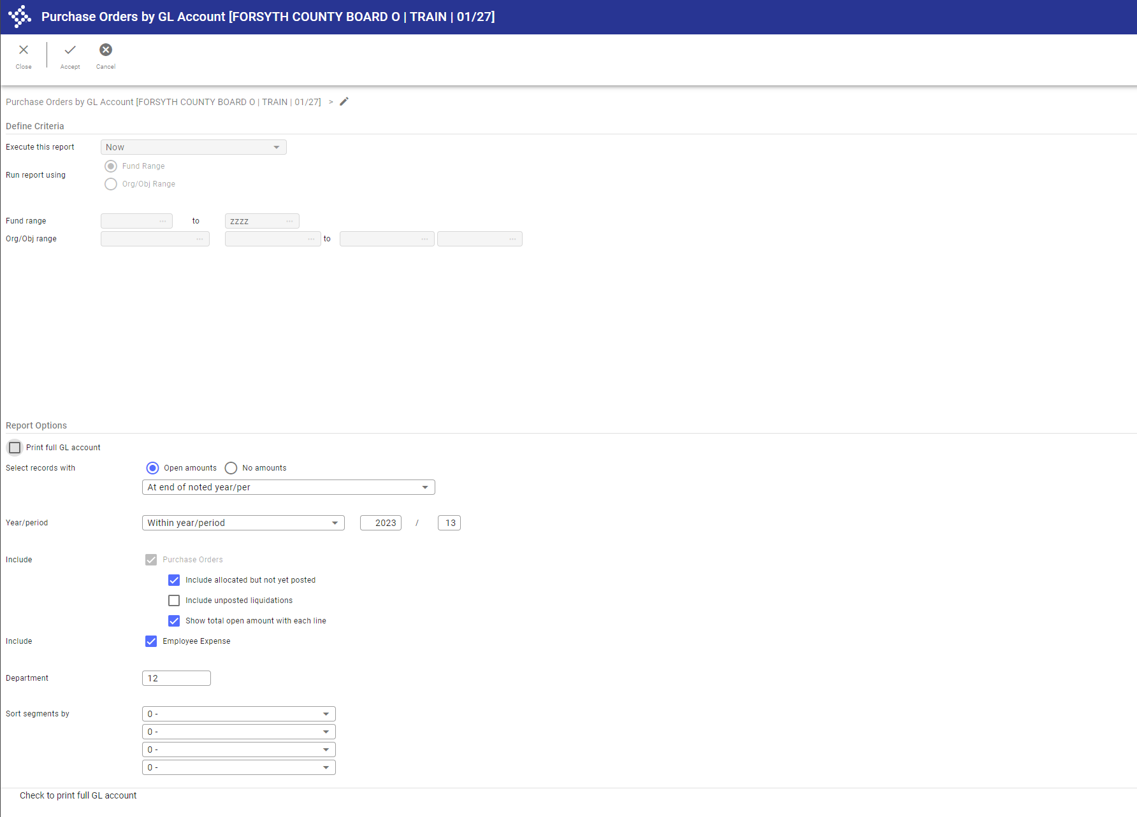
Click on the button to accept this input.

Click the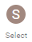 button. The number of records found will be displayed at the bottom of the screen.

After having defined your report you can choose an output format.
- Display will display the report but will not save it anywhere
- Print will print the report but will not save it anywhere
- Create a PDF creates a PDF document that you can then save to your desktop
- Excel Download creates an Excel file that you can then save to your desktop
- The Output button will also allow you to print, save to PDF or Display the report

